Silver oak collage of computer application

Name: Dishang .A. khalashi

No.2204030101908

**1.UNORDER LIST:**

* An unordered list starts with the <ul> tag. Each list item starts with the <li> tag.
* The list items will be marked with bullets (small black circles)
* Syntax: <ul> <li>

**2. ORDER LIST**

* An ordered list starts with the <ol> tag. Each list item starts with the <li> tag.
* The list items will be marked with numbers
* Syntax:<ol><li>

1. **DEFINATION LIST:**

* HTML Description List or Definition List displays elements in definition form in dictionary. The <dl>, <dt> and <dd> tags are used to define description list.
* Syntax:<dl><dt>

1. **NESTED lIST:**

* In HTML documents, you will utilise either the HTML \<ul> or HTML \<ol> elements to construct a nested list. The first element refers to an unordered list, while the second element is used to produce an ordered list
* However, neither of these two ways produces a completely working list withoutthe HTML \<li> element. This tag is used to not only list all of the products you'll need but also to create nested ordered and unordered lists.

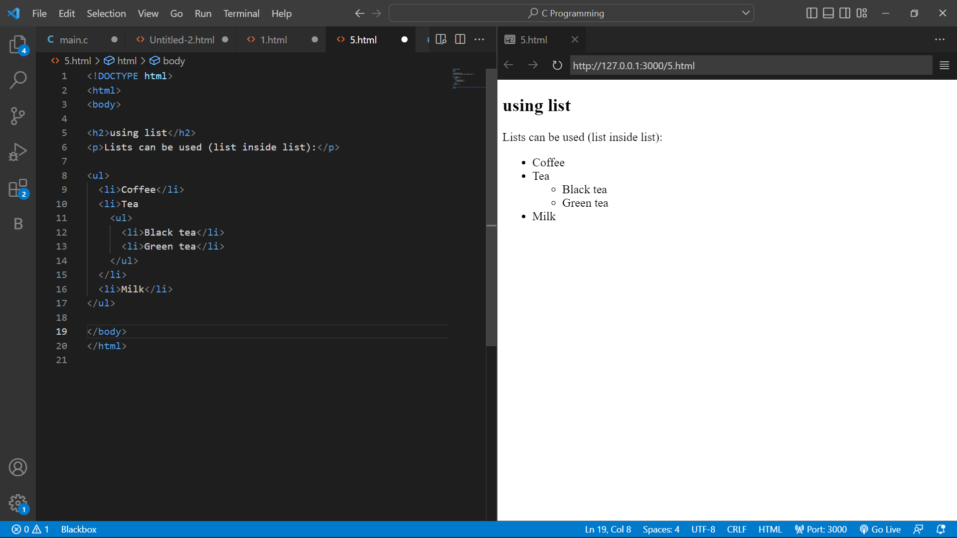

**2.LINK :-**

* HTML links are hyperlinks.
* You can click on a link and jump to another document.
* When you move the mouse over a link, the mouse arrow will turn into a little hand.

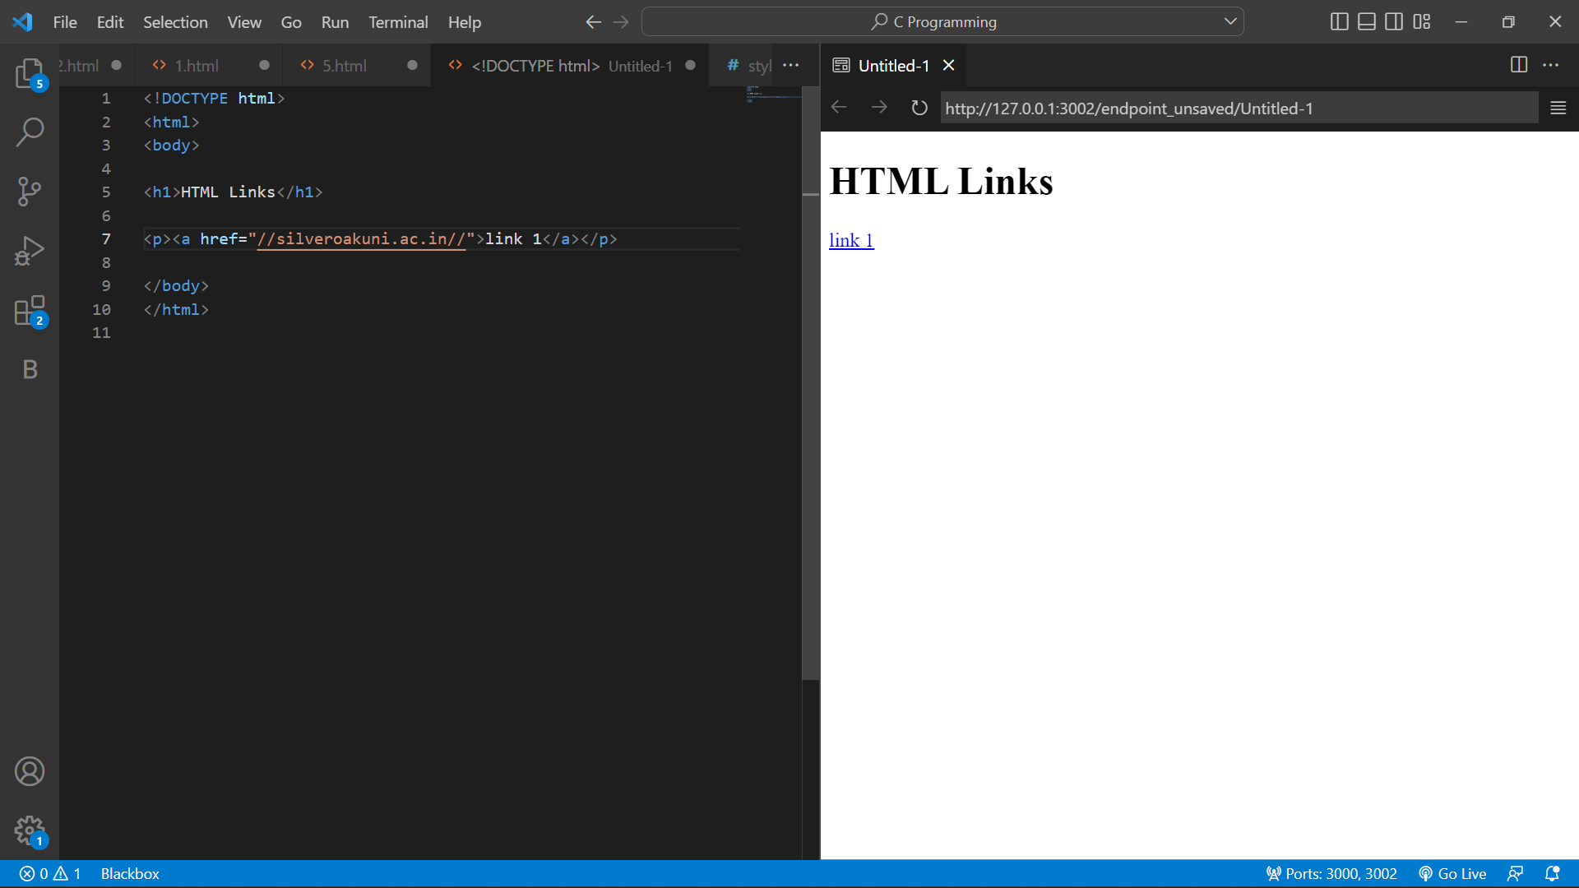

**7.) ROWSPAN & COLSPAN USING CREATE TABLE:**

* HTML tables can have cells that span over multiple rows and/or columns.

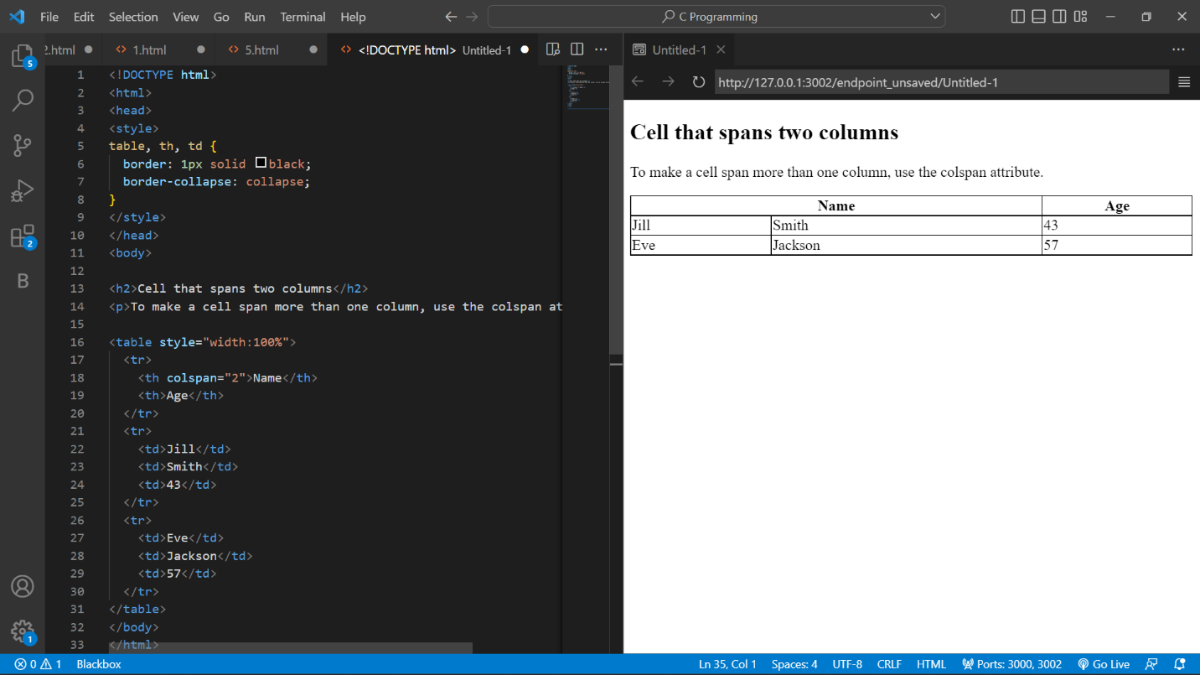

**1.checkbox:**

* The <input type="checkbox"> defines a checkbox.
* The checkbox is shown as a square box that is ticked (checked) when activated.
* Checkboxes are used to let a user select one or more options of a limited number of choices.

**2.Fieldset:**

* The <fieldset> tag is used to group related elements in a form.
* The <fieldset> tag draws a box around the related elements.

**3.Radio Button:**

* The <input type="radio"> defines a radio button.
* Radio buttons are normally presented in radio groups (a collection of radio buttons describing a set of related options). Only one radio button in a group can be selected at the same time.
* **Note:** The radio group must have share the same name (the value of the name attribute) to be treated as a group. Once the radio group is created, selecting any radio button in that group automatically deselects any other selected radio button in the same group. You can have as many radio groups on a page as you want, as long as each group has its own name.
* **Note:** The value attribute defines the unique value associated with each radio button. The value is not shown to the user, but is the value that is sent to the server on "submit" to identify which radio button that was selected.

**4.Selection tag:**

* The <select> element is used to create a drop-down list.
* The <select> element is most often used in a form, to collect user input.
* The name attribute is needed to reference the form data after the form is submitted (if you omit the name attribute, no data from the drop-down list will be submitted).
* The id attribute is needed to associate the drop-down list with a label.
* The [<option>](https://www.w3schools.com/tags/tag_option.asp) tags inside the <select> element define the available options in the drop-down list.

**5.text area:**

* The <textarea> tag defines a multi-line text input control.
* The <textarea> element is often used in a form, to collect user inputs like comments or reviews.
* A text area can hold an unlimited number of characters, and the text renders in a fixed-width font (usually Courier).
* The size of a text area is specified by the cols and rows attributes (or with CSS).
* The name attribute is needed to reference the form data after the form is submitted (if you omit the name attribute, no data from the text area will be submitted).
* The id attribute is needed to associate the text area with a label.

**6. Audio:**

* The controls attribute adds audio controls, like play, pause, and volume.
* The <source> element allows you to specify alternative audio files which the browser may choose from. The browser will use the first recognized format.
* The text between the <audio> and </audio> tags will only be displayed in browsers that do not support the <audio> element.

**7. video tag:**

* After that necessary business surrounding containers, codecs, and licensing issues, it’s time to examine the markup of the video element and its associated attributes.

**8. image tag**

* The HTML <img> tag is used to embed an image in a web page.
* Images are not technically inserted into a web page; images are linked to web pages. The <img> tag creates a holding space for the referenced image.
* The <img> tag is empty, it contains attributes only, and does not have a closing tag.
* The <img> tag has two required attributes:
* src - Specifies the path to the image
* alt - Specifies an alternate text for the image

**9. EXTRA MARKUP (GOOGLE MAP):**

* To mark up a google map in html code to use a ifame in html
* Iframe works with emded links on google map

**10. EXTRA MARKUP (YOUTUBE VIDEO):**

* For markup youtube video in html code using a iframe to show a video link
* Iframe work with embeded link in html

**1.Using list tags:**

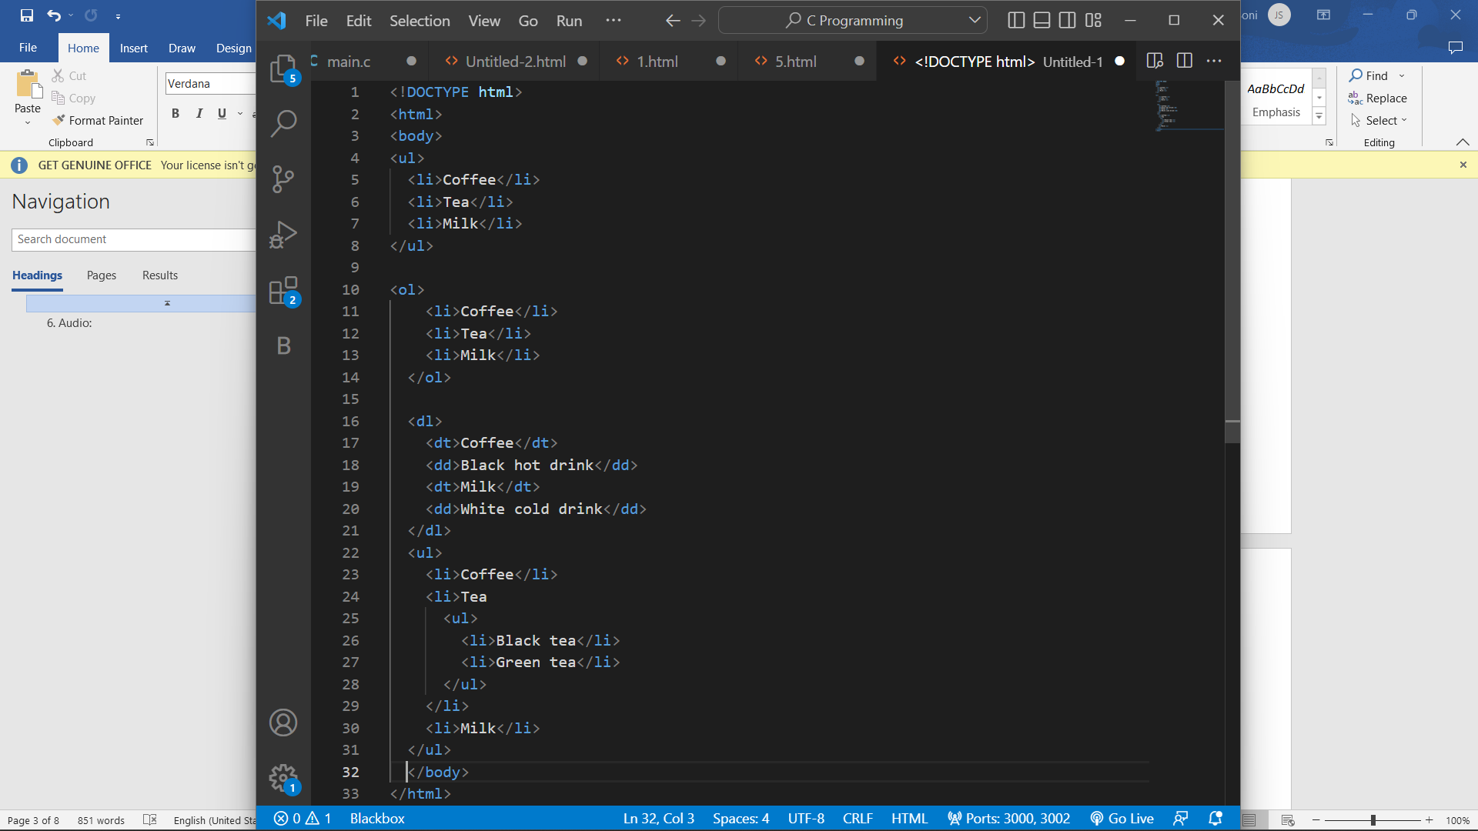

1. **Forms:**

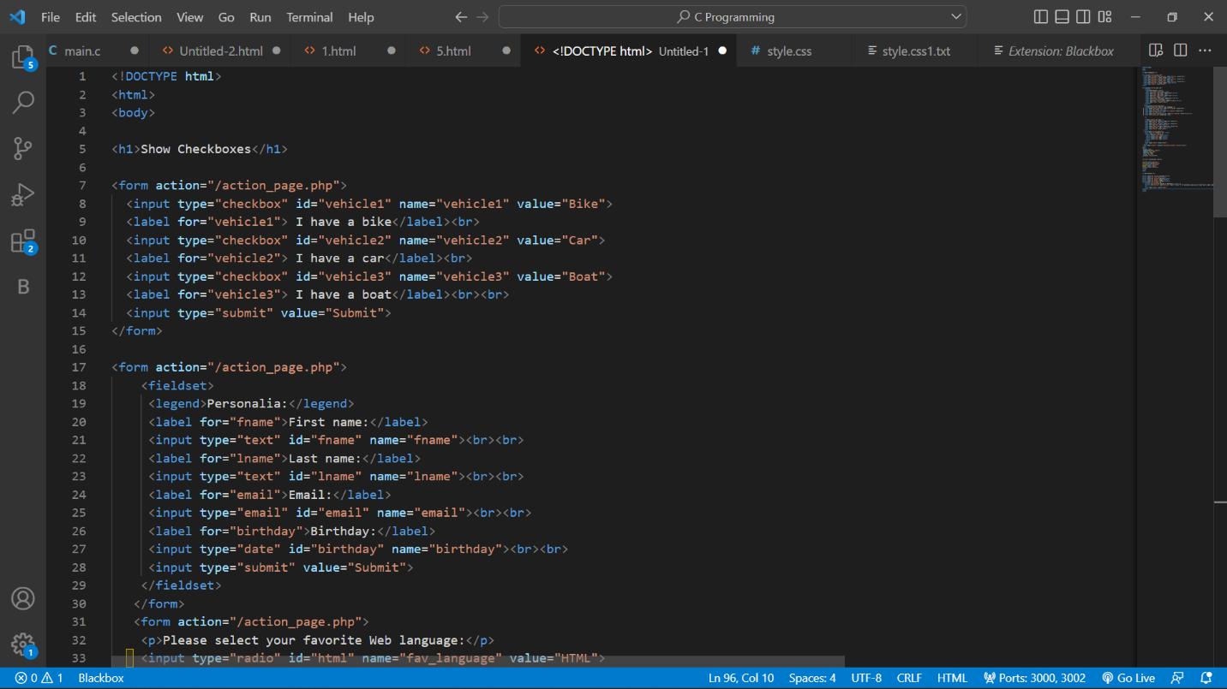

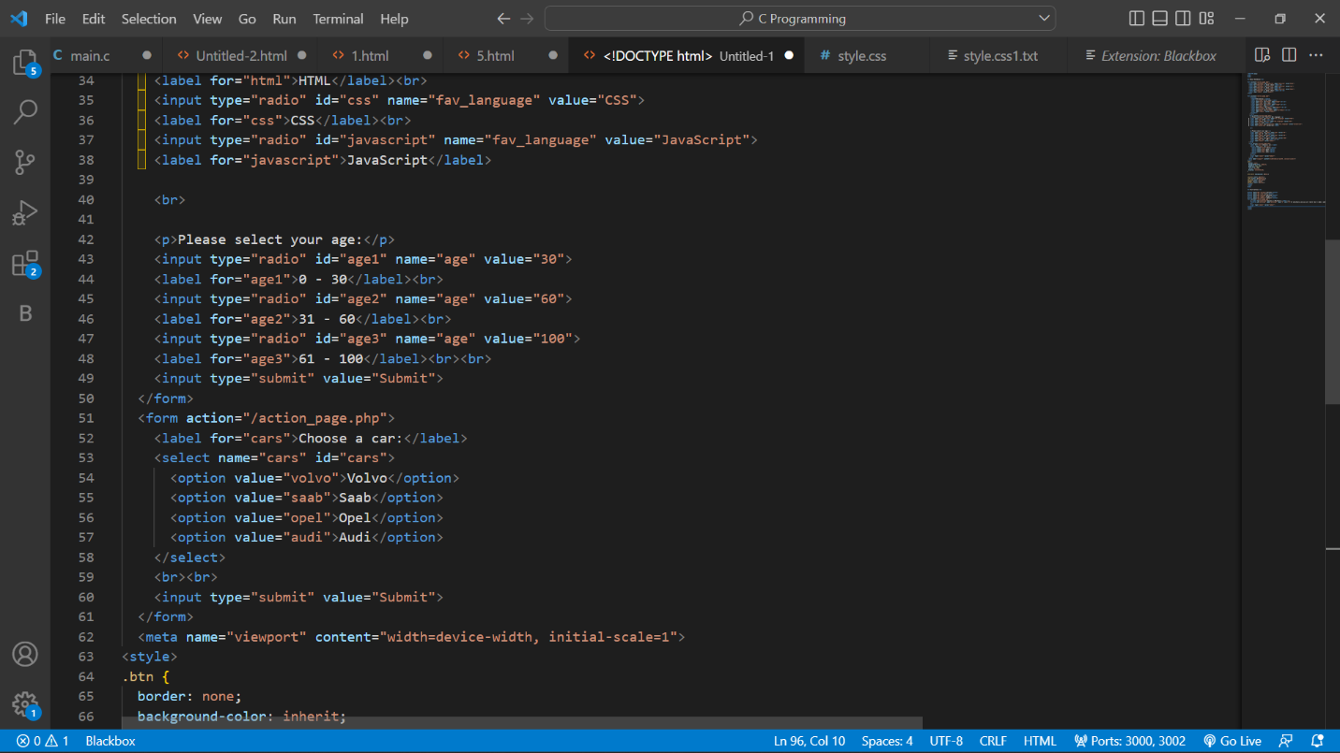

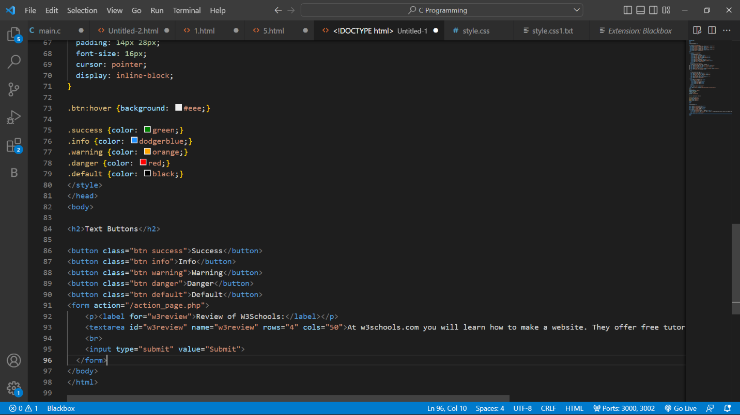

1.Extra markup tags: